**Python Installation on windows**

**Python: Version 3.6.2**

The Python download requires about 30 Mb of disk space; keep it on your machine, in case you need to re-install Python. When installed, Python requires about an additional 90 Mb of disk space.

1. Open [www.python.org/downloads/](http://www.python.org/downloads/)

The following page will appear in your browser.

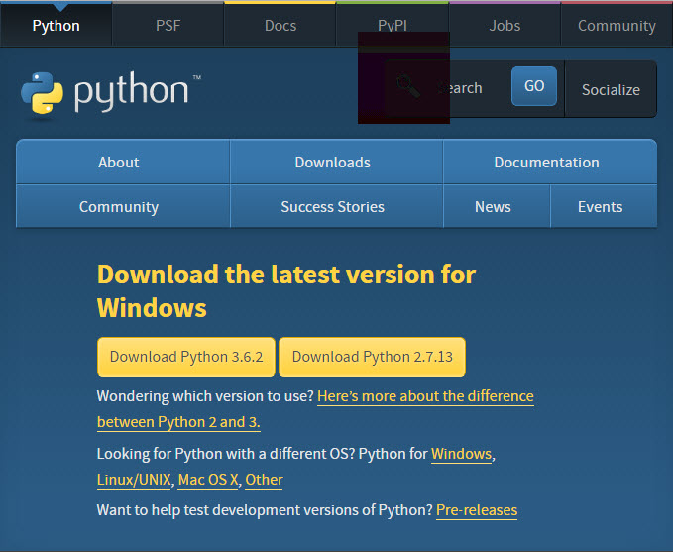

1. Click the **Download Python 3.6.2** button.

The file named **python-3.6.2.exe** should start downloading into your standard download folder.

The file should appear as

https://www.ics.uci.edu/~pattis/common/handouts/pythoneclipsejava/images/python/exefile.jpg

1. Double-click the icon labeling the file **python-3.6.2.exe**.

An **Open File - Security Warning** pop-up window will appear.

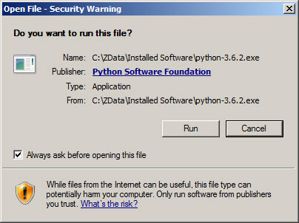

1. Click **Run**.

A **Python 3.6.2 (32-bit) Setup** pop-up window will appear.

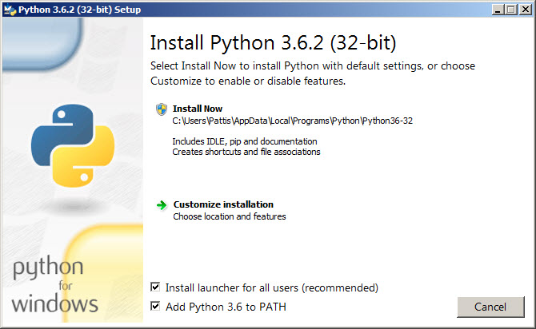

Ensure that the **Install launcher for all users (recommended)** and the **Add Python 3.6 to PATH** checkboxes at the bottom are checked.

1. Highlight the **Install Now** message, and then click it.

A **User Account Conrol** pop-up window will appear, posing the question **Do you want the allow the following program to make changes to this computer?**

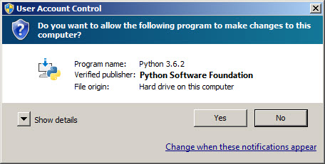

1. Click the **Yes** button.

A new **Python 3.6.2 (32-bit) Setup** pop-up window will appear with a **Setup Progress** message and a progress bar.

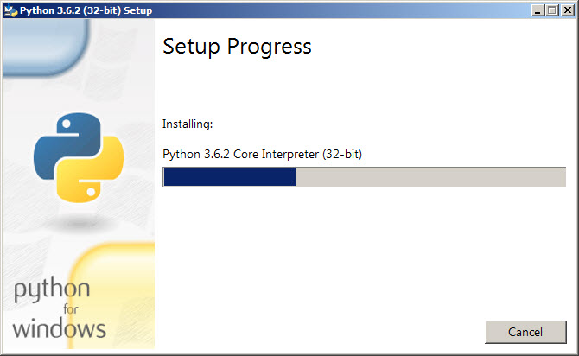

a new **Python 3.6.2 (32-bit) Setup** pop-up window will appear with a **Setup was successfuly** message.

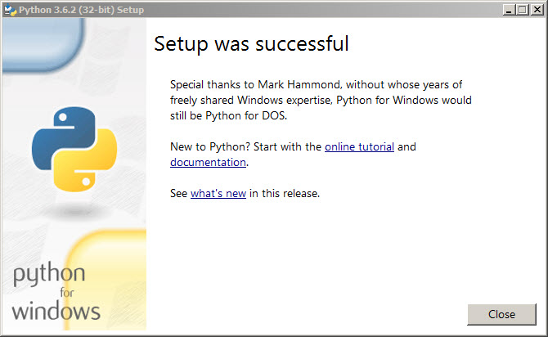

1. Click the **Close** button.

Python should now be installed.

**Installing Python on Linux**

1. Check to see if Python is already installed:

$ **python --version**

1. If Python 2.7 or later is not installed, install Python with your distribution's package manager.
   * The command and package name varies:

**On Debian derivatives such as Ubuntu, use APT:**

$ **sudo apt-get install python3**

**On Red Hat and derivatives, use yum:**

$ **sudo yum install python**

**On SUSE and derivatives, use zypper:**

$ **sudo zypper install python3**

1. Open a command prompt or shell and run the following command to verify that Python installed correctly:

$ **python3 --version**

Python 3.6.2